Rift ressources

Level Resource Node Yield Type Screenshot Notes
1 Coastal Glory Coastal Glory Plant
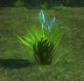
Freemarch, Silverwood
1 Grieveblossom Grieveblossom Petals Plant
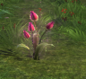
Freemarch, Silverwood
1 BloodbriarBloodbriar Stems
Plant Stonefield
1 Yew Log Yew Timber Wood
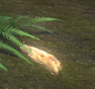
Freemarch, Silverwood
1 Corpseblossom Corpseblossom Petals Plant Moonshade Highlands

30 Creeperbrush Creeperbrush Roots Plant
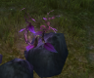
Freemarch, Stonefield

35 Ashwood Log Ashwood Timber Wood
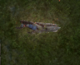
Freemarch, Stonefield

70 Razorbrush Razorbrush Leaves Plant
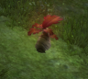
Stonefield, Scarlet Gorge
70 Krakenweed Krakenweed Stems Plant
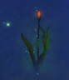
Stonefield, Scarlet Gorge

75 Oak Log Oak Log Wood
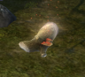
Stonefield, Scarlet Gorge

80 Golden Nettle Evergreen Nettle Stems
Golden Nettle Stems
Potent Sap Plant
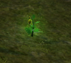
Stonefield, Scarlet Gorge, Scarwood Reach
80 Duskglory Duskglory Petals
Potent Sap Plant
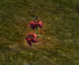
Stonefield, Scarlet Gorge, Scarwood Reach

115 Mahogany Log Mahogany Log Wood
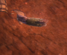
Scarlet Gorge, Scarwood Reach, Stonefield
115 Wyvernspurr Wyvernspurr Stems
Potent Sap Plant
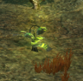
Scarlet Gorge, Scarwood Reach, Droughtlands

140 Tattertwist Tattertwist Leaves, Pure Sap Plant Scarwood Reach, Moonshade Highlands

145 Roc Orchid Roc Orchid Petals
Pure Sap Plant
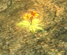
Stillmoor, Scarwood Rach, Droughtlands, Moonshade Highlands, Iron Pine Peak, Shimmersand
145 Kingswood Log Kingswood Log Wood
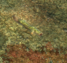
Shimmersand, Scarwood Reach, Droughtlands, Moonshade Highlands

180 Drakefoot Drakefoot Stems
Drakefoot Seed Plant
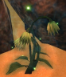
Shimmersand, Droughtlands, Iron Pine Peak

185 Runebirch Log Runebirch Log Wood
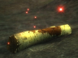
Moonshade Highlands, Iron Pine Peak, Stillmoor

200 Asturn Pine Asturn Pine Wood Moonshade Highlands
200 Gently Used Arrows Gently Used Arrows Wood
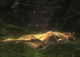
Stillmoor
200 Bloodshade Bloodshade Petals Plant
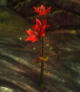
Stillmoor, Iron Pine Peak, Shimmersand

225 Basiliskweed Basiliskweed Stems Plant
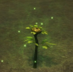
Stillmoor, Shimmersand, Droughtlands
225 Sagebrush Log Sagebrush Timber Wood
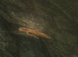
Iron Pine Peak, Stillmoor, Shimmersand, Ember Isle

230 Fleur de Tempête
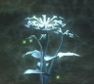
Stillmoor, Shimmersand, Ember Isle

250 Twilight Bloom Twilight Bloom Roots
Pristine Sap Plant
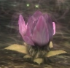
Iron Pine Peak, Charmer's Caldera, Abyssal Precipice, Stillmoor, Ember Isle
250 Ombrépine
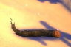
Iron Pine Peak, Charmer's Caldera, Abyssal Precipice, Stillmoor, Ember Isle

Ores
All ore deposits become trivial 50 levels above the minimum and will give no experience gain after that.
level | Ore | Gems | Thumbnail | Locations
1 | Tin Lode  - Tin Ore  - Fieldstone | Moonstone  Sunstone | 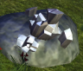 | Freemarch, Silverwood
1 | Ore Bits †  - Agate | Valeglass Agate  Skystone Agate | 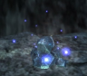 | Stonefield (inside the skull at Titan's Rest)
35 | Copper Vein  - Copper Ore  - Opal  - Unusual Ore | Shimmering Opal  Abyssal Opal | 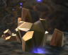 | Freemarch, Silverwood, Stonefield, Gloamwood
75 | Iron Vein  - Iron Ore  - Geode | Celestite  Heartstone | 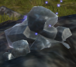 | Stonefield, Gloamwood, Scarlet Gorge
80 | Silver Vein  - Silver Ore  - Geode  - Beryl | Celestite  Heartstone  Blood Berylite  Radiant Emerald | 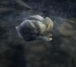 | Stonefields, Gloamwood, Scarlet Gorge, Scarwood Reach
115 | Chromite Vein  - Chromite Ore  - Beryl  - Discarded Pickaxe Head | Blood Berylite  Radiant Emerald | 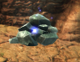 | Scarlet Gorge, Scarwood Reach
145 | Cobalt Lode  - Cobalt Ore  - Agate  - Mysterious Ore | Valeglass Agate  Skystone Agate | 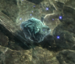 | Scarwood Reach, Droughtlands, Moonshade Highlands
150 | Gold Vein  - Gold Ore  - Agate  - Corundum | Valeglass Agate  Skystone Agate  Sapphire  Ruby | 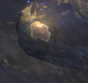 | Scarwood Reach, Shimmersand, Droughtlands
185 | Titanium Vein  - Titanium Ore  - Corundum  - Mysterious Ore | Sapphire  Ruby | 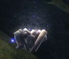 | Stillmoor, Shimmersand, Droughtlands, Iron Pine Peak, Moonshade Highlands
200 | Corolane Powder  - Corolane Powder |  | 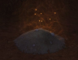 | Scarlet Gorge
225 | Carmintium Deposit  - Carmintium Ore  - Diamond  - Glinting Nugget | Brilliant Diamond  Lightsbane Diamond | 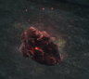 | Iron Pine Peak, Stillmoor, Shimmersand, Charmer's Caldera, Abyssal Precipice, Ember Isle
230 | Platinum Deposit  - Platinum Ore  - Diamond  - Lightspar Agate  - Glinting Nugget | Brilliant Diamond  Lightsbane Diamond  Smooth Lightstone  Jagged Lightstone | 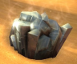 | Iron Pine Peak, Stillmoor, Shimmersand, Charmer's Caldera, Abyssal Precipice, Ember Isle
250 | Orichalcum Deposit  - Orichalcum Ore  - Lightspar Agate  - Glinting Nugget | Smooth Lightstone  Jagged Lightstone | 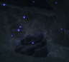 | Iron Pine Peak, Stillmoor, Shimmersand, Charmer's Caldera, Abyssal Precipice, Ember Isle
† Mining is not required to harvest Ore Bits. Anyone can harvest this resource.

