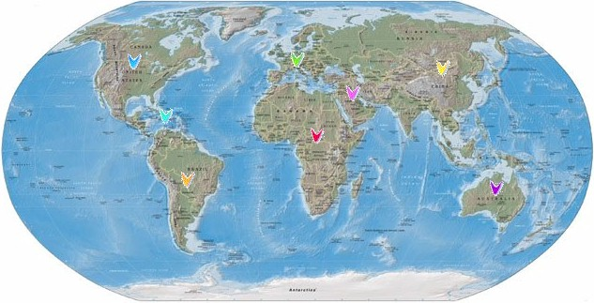

MEDICATION WITHOUT ANY BOUNDARY

FRENCH COMPANY EXPERT IN THE
HEALTH FIELD

LOCATED IN AVIGNON, IN THE SOUTH OF FRANCE

CLOSE TO 2 MAIN AIRPORTS :

. MARSEILLE PROVENCE
. NIMES

CLOSE TO 2 PORTS :

. MARSEILLE
. SETE

A CONSTANT LINK WITH CHEMISTS AND MEDICAL PRACTITIONERS

TEL : 33(0). 490. 89. 20. 90

FAX : 33(0). 490. 89. 20. 93

E.MAIL : contact@memo-pharma.fr

Pharmacist - Manager
ALBERT MERCURY

Export Manager
LUC MERCURY

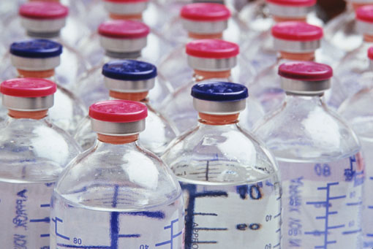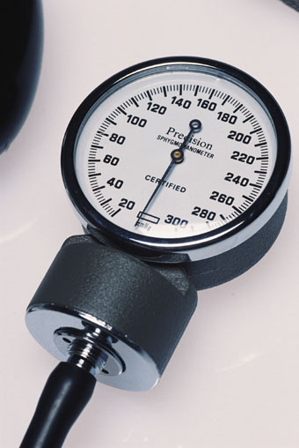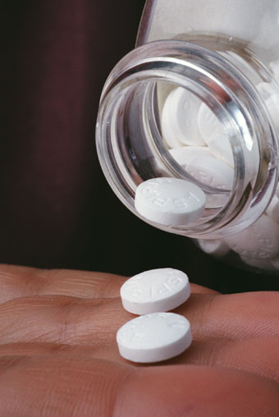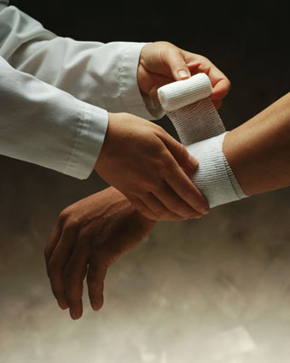A COMPLETE RANGE IS

AVAILABLE TO YOU :

MEDICINES : Any patent medicine which is assessed by the Health Authority

ACCESSORIES : Médico-surgical and orthopaedic material .

CONSUMABLES : Cotton wool, compresses, bandages, plasters, syringes, gloves, sutures, etc…

VETERINARY PRODUCTS : 4000 available products.

PERFUMES AND COSMETICS.

MEDICAL MATERIAL .

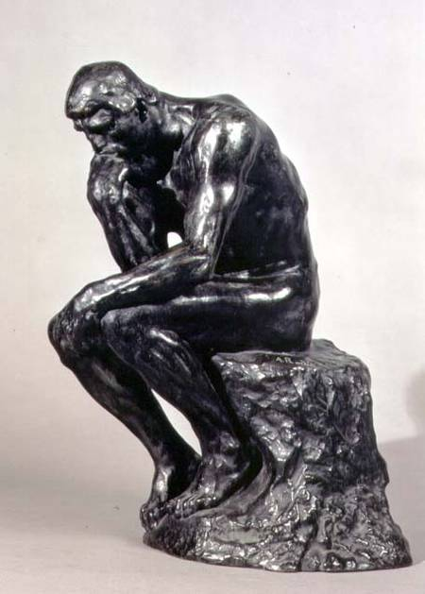

OUR SCIENTIFIC DATABASE

IS AVAILABLE

26000 FRENCH AND FOREIGN PATENT MEDICINES WITH THEIR EQUIVALENT INTERNATIONAL COMMON DESIGNATIONS

ALL THE NEW MOLECULES

INFORMATION ON ALL MEDICINES AND ACCESSORIES
( only available in French)

MEMO PHARMA EXPORT

OUR PARTNERS :

PHARMACY - DRUGSTORES

PUBLIC HOSPITALS

PRIVATE CLINIC

NATIONAL WHOLESALERS

STATE ORGANISATIONS
- FREE HEALTH CENTRES
- LABORATORIES
- VETS

MEMO PHARMA EXPORT

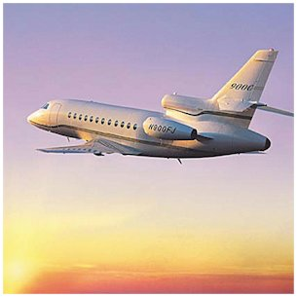
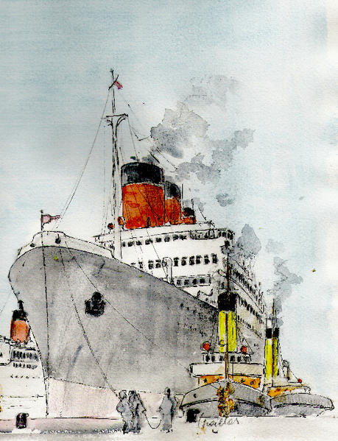

QUICK DELIVERIES THROUGH
INTERNATIONAL CARRIERS

BULK AIR FREIGHT

SEA FREIGHT FOR HEAVY PRODUCTS
( weekly boat departures )

IMMEDIATE EMERGENCY SERVICE

MEMO PHARMA EXPORT

MEDICINES

PATENT MEDICINES
ANY URGENT ORDER CAN BE DELIVERED EVERY DAY THROUGH INTERNATIONAL EXPRESS MAIL WITH PREFERENTIAL RATE

THE ORDERS MUST BE SENT BEFORE NOON.
NO MINIMUM QUANTITY IS REQUIRED

AIR OR SEA FREIGHT FOR HEAVY OR BULKY ORDERS

MEMO PHARMA EXPORT

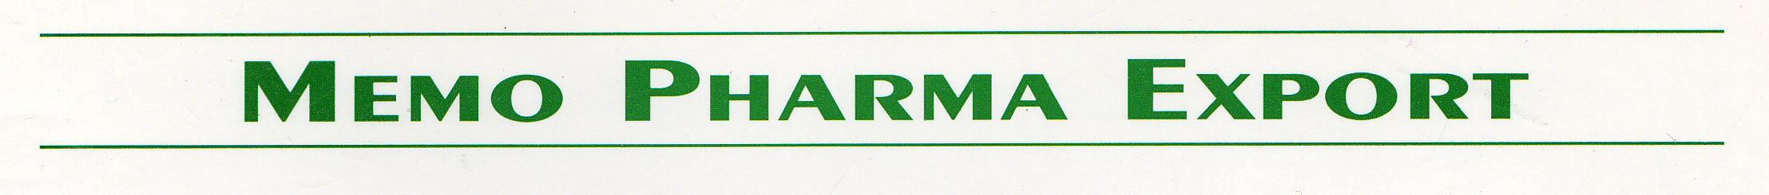

INTERNATIONAL PHARMACEUTICAL DISTRIBUTOR

14, AVENUE DE L’ETANG
Z.I FONTCOUVERTE
84000 – AVIGNON

FRANCE

